Software Requirements Specification
for
Distributed system for the management of an airline company’s flights
Version 1.5 approved
Prepared by Enculescu Bianca, Dobritoiu Vlad, Dobritoiu Tudor
ACE.UCV
27.02.2021
Table of Contents
Table of Contents ii
Revision History ii
1. Introduction 1
1.1 Purpose 1
1.2 Document Conventions 1
1.3 Intended Audience and Reading Suggestions 1
1.4 Product Scope 1
1.5 References 1
2. Overall Description 2
2.1 Product Perspective 2
2.2 Product Functions 2
2.3 User Classes and Characteristics 2
2.4 Operating Environment 2
2.5 Design and Implementation Constraints 2
2.6 User Documentation 2
2.7 Assumptions and Dependencies 3
3. External Interface Requirements 3
3.1 User Interfaces 3
3.2 Hardware Interfaces 3
3.3 Software Interfaces 3
3.4 Communications Interfaces 3
4. System Features 4
4.1 User access to application 4
4.2 Registration process 4
4.3 Admin capabilities 4
4.4 Making resrvations 4
4.5 User profile page 4
4.6 General functions and others 4

5. Other Nonfunctional Requirements 4
5.1 Performance Requirements 4
5.2 Safety Requirements 5
5.3 Security Requirements 5
5.4 Software Quality Attributes 5
5.5 Business Rules 5
6. Other Requirements 5
Appendix A: Glossary 5
Appendix B: Analysis Models 5
Appendix C: To Be Determined List 6

Revision History
Name | Date | Reason For Changes | Version
Dobritoiu Vlad | 27.02.21 | Beginning of development- Introduction (Purpose, Document Conventions, Intended Audience and reading Suggestions) | 1.0
Enculescu Bianca | 03.02.21 | Overall description + Other nonfunctional requirements | 1.1
Dobritoiu Tudor | 05.03.21 | External interface requirements | 1.2
Dobritoiu Vlad, Enculescu Bianca | 08.03.21 | Revision to: Introduction, Overall description, Other nonfunctional, External interface requirements | 1.3
Dobritoiu Vlad, Enculescu Bianca, Dobritoiu Tudor | 10.03.21 | Overall revisions and other small changes+ Added system features | 1.4
Dobritoiu Vlad, Enculescu Bianca, Dobritoiu Tudor | 11.03.21 | Final changes | 1.5

Introduction

Purpose
This document describes the software requirements and specifications for an airline flights management software application, version 1.0, and covers all the necessary information (functional and technical) about this project.
The purpose of this project is the design and development of a software system meant for automizing the process of managing flights and flight reservations for an airline company.

Document Conventions
In this document the chapter names are represented by text written in bolded letters with the “Times” font, size 14. The chapter will be divided in subchapters (letters of size 14). Anything belonging to a subchapter will be written in Arial, size 11.

Abbreviations:
HTML = Hypertext markup language
CSS = Cascading style sheet
HTTP = Hypertext transport
UI= User interface

Intended Audience and Reading Suggestions
This is document is meant to be examined by anybody interested in documenting themselves about the development of this project. This may include: the developers, the users, the documentation writers, etc.

The document will contain information about the final capabilities of the software, the tools, the frameworks used to complete the software, how to use the software and others.

For better readability we suggest reading the document in the order that it is presented.

Product Scope
The product consists of a web application for an airline flights management system which provides the users with the possibility of logging into the application, booking and buying tickets to one or more flights and getting the information needed about said flights. The software is meant to provide an easy way of managing and organizing such actions and to collect the necessary information for making them possible.

The software consists of the user interface, data server, application server and a web server. This system has goal of making the process of flight booking easier and more reliable for the passengers and providing better management capabilities for the company. The application will be able to:
-collect data about the flights
-manage passenger information
-generate reports
-provide information through a web portal
-query the system
-manage the flow of documents for making reservations

References
[1] IEEE Software Engineering Standards Committee, “IEEE Std 830-1998, IEEE Recommended Practice for Software Requirements Specifications”, October 20, 1998.

https://www.ryanair.com/ro/ro
https://wizzair.com/en-gb#/
https://www.w3schools.com/
https://www.codecademy.com/
https://www.pluralsight.com/
http://www.tutorialsteacher.com/
https://www.freecodecamp.org/
https://www.tutorialspoint.com/
https://developer.mozilla.org/
https://www.pluralsight.com/courses/understanding-aspdotnet-core-2x/
https://www.toptal.com/angular/angular-5-asp-net-core/

Overall Description

Product Perspective
This is a self-contained product with the goal of optimizing the flight booking process of an airline company by using a web portal and databases. The product consists of a web application which provides the users with the possibility of logging into the application, buying tickets to one or more flights and getting the information needed about said flights, a database for storing information about the clients, an application server that manages clients, accounts and transactions and a web server.

Product Functions
The system will enable the company to manage the passengers and the flights.

The user will be able to:
-register and login into an account
-buy tickets to one or more flights
-mention the payment method and the date that the payment will be executed
-check information about the flights
-will identified by name, surname, phone, e-mail, address
-generate reports (according to the allocated rights)

The application will:
-store data about flight and reservations:
-store the date and the class of the reservation
-manage the flights by capacity, id number, source and destination, departure and
arrival times, the type of aircraft
-permit database management from the browser with offline back up support and retrieval of data.
-will display data in table form

User Classes and Characteristics
There will be 3 types of users.
Unregistered and not logged in user:
-able to look for the available flights
-able purchase tickets only after providing an email address and the required personal information when booking the flights

Registered and logged in users:
-able to look for the available flights
-able to book flights without the need of providing the personal information at the purchase of a flight
-able to see his reservations history

Admin:
-able to perform flights, user account and reservation administration from the browser

Operating Environment
The user interface will function in browsers such as Google Chrome or Microsoft Edge on the Windows 10 Operating systems.

Design and Implementation Constraints
Development tools: Visual Studio community 2019, Eclipse IDE, Visual studio Code 2019, Google Chrome (for web browser access).
Frameworks and technologies: Java, HTML, CSS, HTTP, SQL server, JSP, AJAX, JavaScript, jQuery.
Other development constraints: internet connection (for connection to the server and database).

User Documentation
The user will have access to the Software Requirements Specification document of the application and to a power point document explaining some functionalities of the user interface.

Assumptions and Dependencies
It is assumed that different users might access the application from different browsers, which depending on the type and version may produce different results than expected or may cause performance issues.

External Interface Requirements

User Interfaces
This section will show some examples of how some of the user interface pages will look like.

Registration page for new users and Login page:
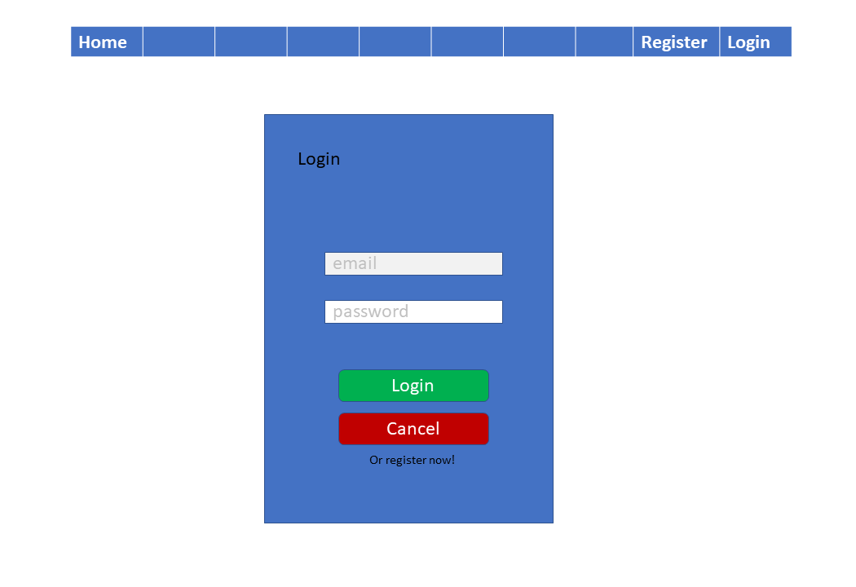
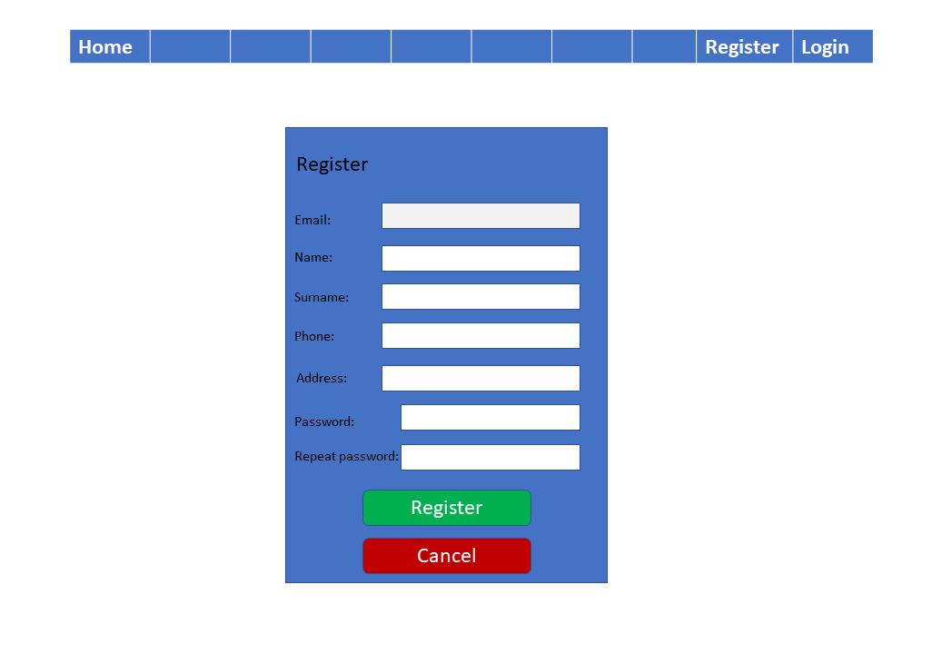

Home page (not logged in and logged in user):
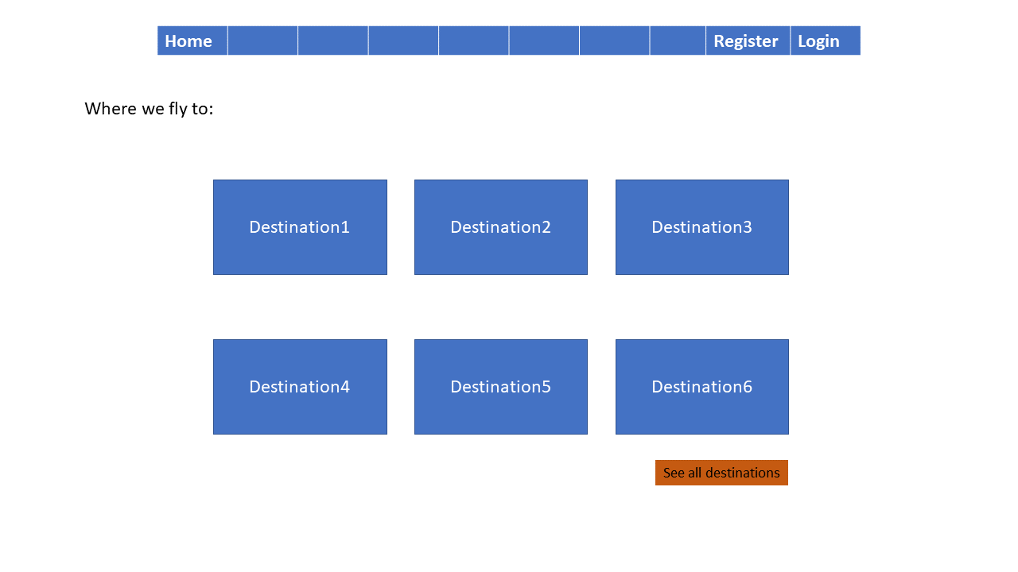
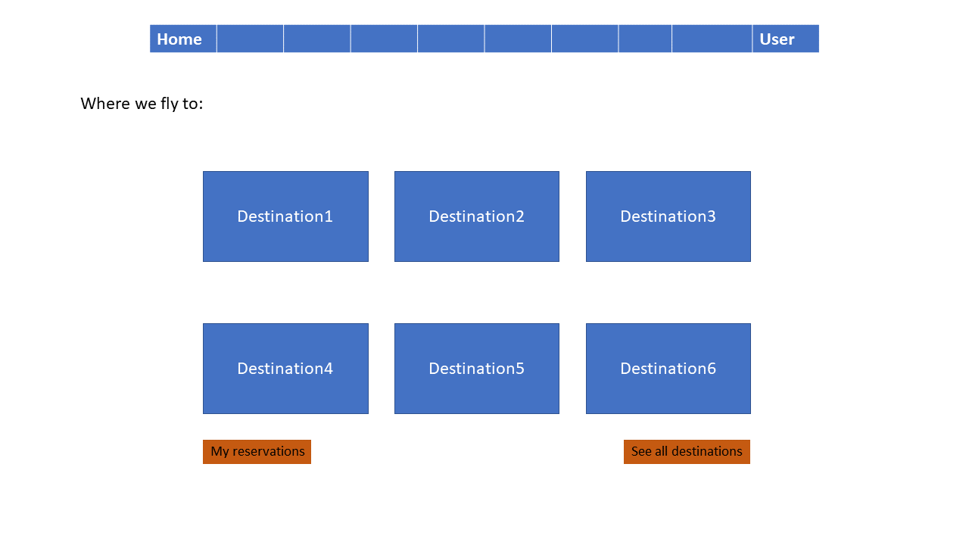

Flight reservation page:

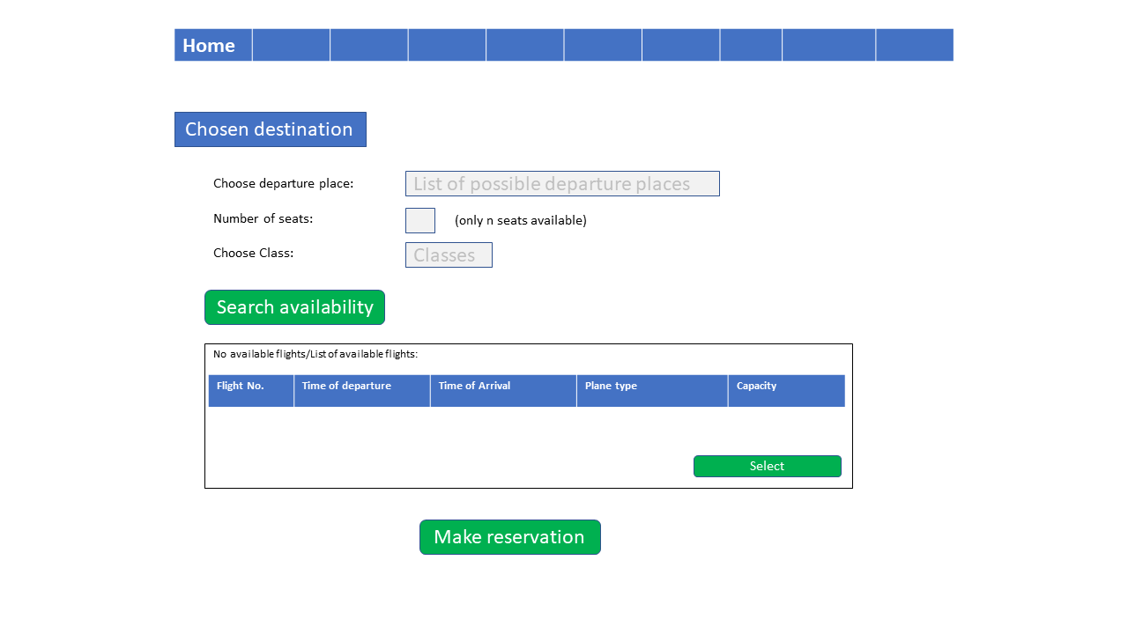

Pages for completing a reservation (not logged in and logged in):
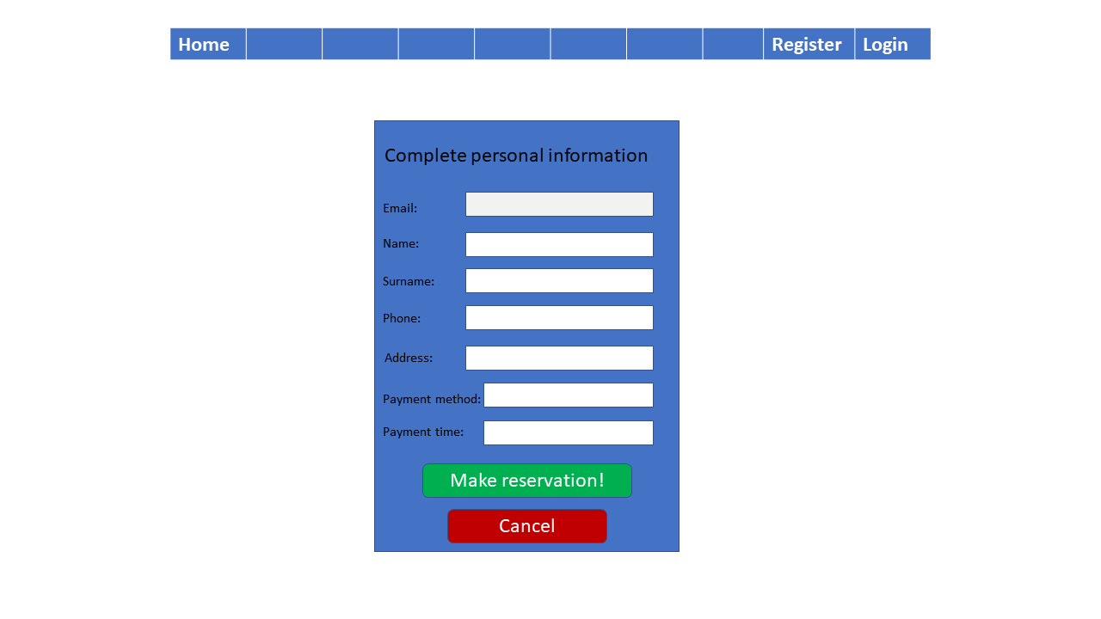
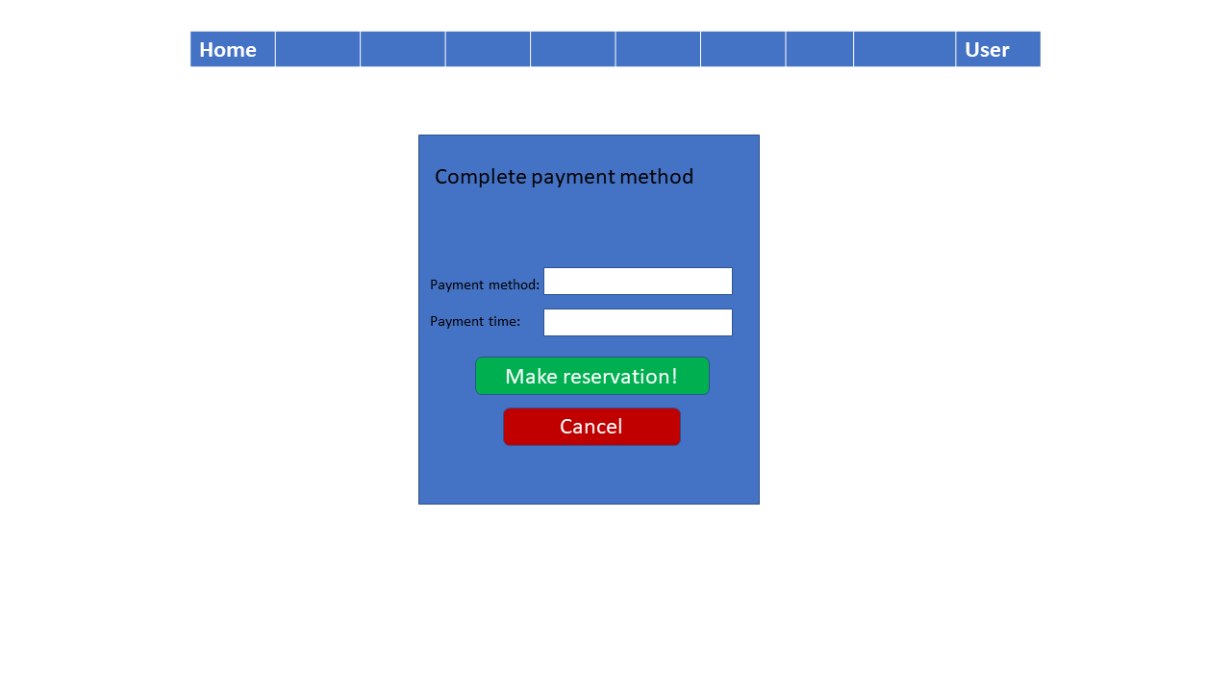

Reservation history page for logged users:

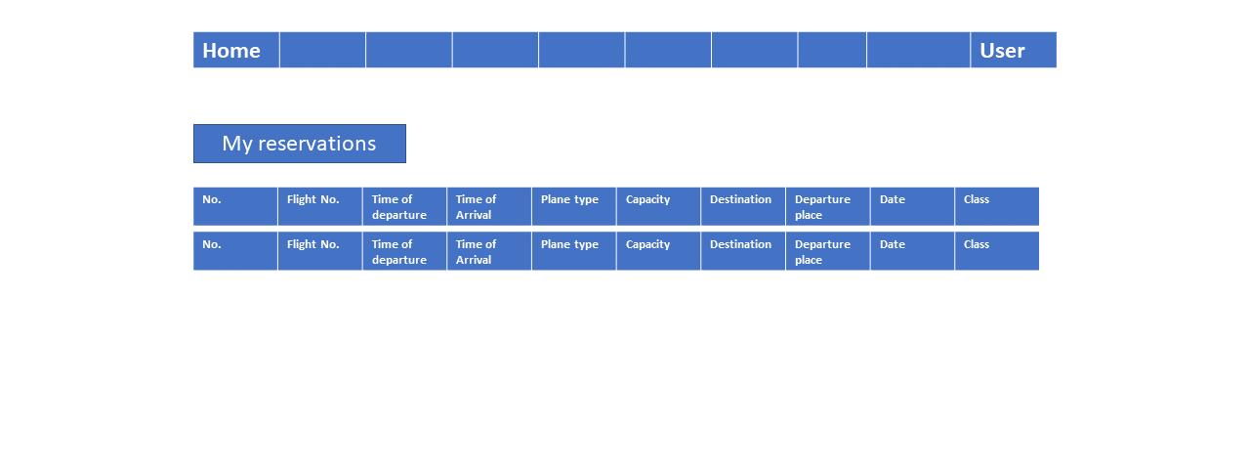

Admin view of flights:

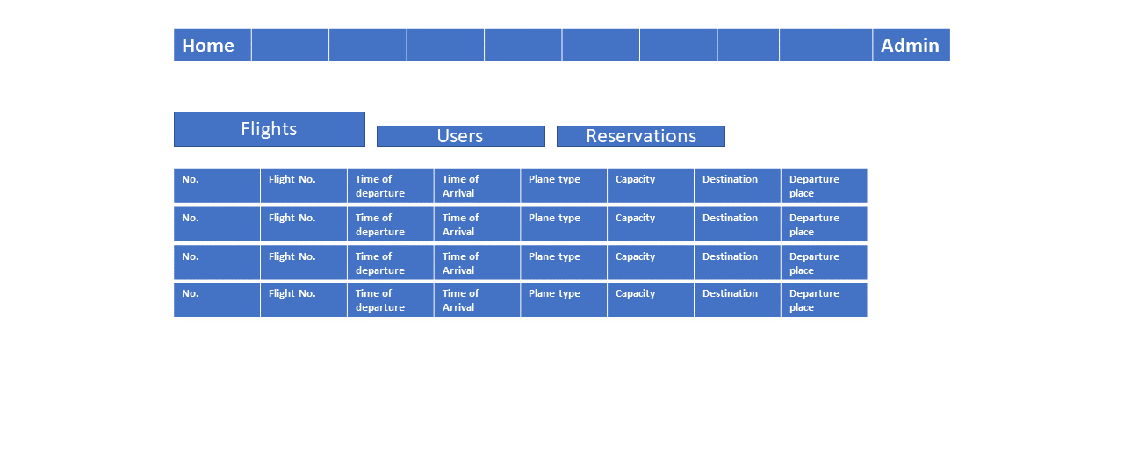

Page with all possible destinations:
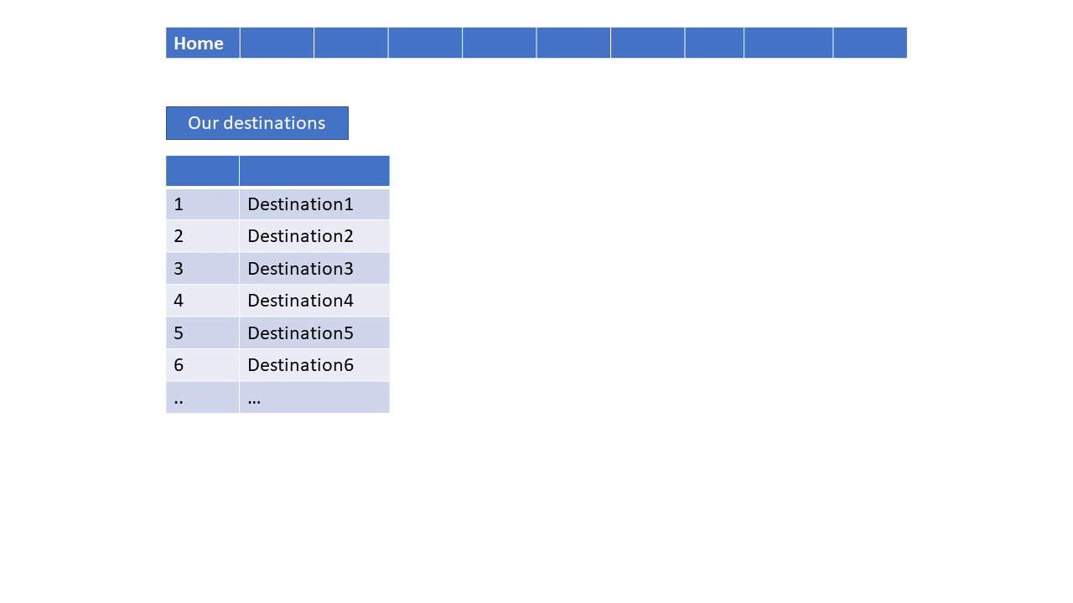

Hardware Interfaces
NA

Software Interfaces
The application will communicate with the server through two functions:
-sendRequest(query) for interrogating the Database
-receiveData() for receiving data returned by the Database

Communications Interfaces
Communication standards: HTTP

System Features

User access to application
4.1.1 Description and Priority
This feature should be considered high priority as it provides access to the application for the users.
4.1.2 Stimulus/Response Sequences
NA
4.1.3 Functional Requirements
REQ-1: When opening the application, the user will be able to access the Home page of the UI even without being logged in into an account.
REQ-2: The user will have the options to access the log in page, access the registration page or to choose a destination and start the flight reservation process.
REQ-3: The user can register into the application by creating a new account.
REQ-4: Accounts must differ from one another by email address.
REQ-5: The user can log in only with an already existing account. He must provide the email address and the correct password in the specified fields on the login page.
REQ-6: After log in the user will be redirected to the home page specified to a logged in user.

Registration process
4.2.1 Description and Priority
This feature should be considered high priority as it provides the user the ability to create an account in the application.
4.2.2 Stimulus/Response Sequences
The user will provide his personal information as input and in return will be able to access the features of the software meant for the registered users only.
4.2.3 Functional Requirements

REQ-7: For registration, the user will need to provide into a form the following information: e-mail address (that doesn’t already been used), name, surname, address, phone number, a password and to check a box that conforming his age is over 13.
REQ-8: After completing the form the data will be send to the server which will check if an account has already been created with that e-mail address and if the password has been introduced correctly.
REQ-9: If the registration is validated by the server it will be confirmed to the user and the information will be stored in the database.
REQ-10: If the registration is not valid the user will receive a message and will be redirected to the registration page to reenter the wrong credentials.

Admin capabilities
4.3.1 Description and Priority
This feature should be considered high priority. Here we describe the scope of the admin capabilities.
4.3.2 Stimulus/Response Sequences
The admin can provide the server with updates and modifications to the list of flight and users. The modifications will propagate into the database and will be visible in browser.

4.3.3 Functional Requirements

REQ-11: The Admin user will be able to log into his account as any other user.
REQ-12: He will have access to an administration page.
REQ-13: The administration page will contain table with lists of all the flights, all the users and all the reservations.
REQ-14 The tables will be available at the press of the corresponding buttons.
REQ-15: The Admin will be able to change information about the flights and users in the administration page. The changes will also modify the database.
REQ-16 The changes will be performed in the table of contents.
REQ-17 If the changes are not suitable an error massage will notify the administrator and the said changes will not be saved.
REQ-18: The admin will be able to add and delete flights. The new flight will need to be provided with all the necessary information: number, capacity, destination, departure, arrival time, departure time, plane type.
REQ-19 The changes will be applied to the database only after pressing the button “save changes”.

Making reservations
4.4.1 Description and Priority
This feature should be considered high priority. This set of requirements shows what is needed to make the creation of a reservation possible and complete.
4.4.2 Stimulus/Response Sequences
As input, the user provides details about the wanted flight and receives information about available flights. Also provides payments information.
4.4.3 Functional Requirements

REQ-20: Reservation process must begin in the home page where the user will see some destinations with the possibility of seeing the whole list of destinations at the press of the “See all destinations” button. The logged user can also access his reservation history page from here.
REQ-21: By choosing the destination the user will be redirected to the reservation page.
REQ-22: The reservation page will ask the user to complete three fields: departure place, number of seats and class. All three are obligatory.
REQ-23: The user will press the “search availability” button which will ask the server to search the database for the available flights that meet the requirements.
REQ-24: The server will provide a list of said flights and display the list to the user. If no flights meet the requirements or if the capacity of the plane in that class is met, the page will display “No available flights”.
REQ-25: The user will be able to choose a convenient flight by clicking it and then pressing the “select” button.
REQ-26: The user will be able to press the “Make reservation” button only after a flight was selected.
REQ-27: The “make reservation” button will open payments page.
REQ-28: If the user is logged into an account, he will be redirected to a payment page specific to logged users. The user will have to complete the payment method and time of payment.
REQ-29: If the user is not logged into an account, he will be redirected to a payment page specific to non-logged users. The user will have to complete the payment method, time of payment, name, surname, email, phone, address.
REQ-30: By pressing the “Make reservation!” button the logged in user will be redirected to the user reservations page where he will see the list of his reservations with the new one added.
REQ-31: By pressing the “Make reservation!” button the non-logged user will be redirected to the home page.
REQ-32: The reservations will be stored in the database and will contain the details about the user that made them, the flight, and he time when they were made.

User profile page
4.5.1 Description and Priority
This feature should be considered medium priority.
4.5.2 Stimulus/Response Sequences
By accessing the profile page, the user is provided with his personal information. The user can make changes to this set of data.
4.5.3 Functional Requirements

REQ-33 The user profile page can be accessed only by logged in users.
REQ-34 The user will be able to change his personal information such as name, surname, phone, or address.
REQ-35 The user cannot change his email address.
REQ-36 The user will be able to reset his password from the user profile page. The rest can be done only after providing the old password, and the new password twice.
REQ-37 The changes the user makes in the profile page will be transmitted to the database.

General functions and others
4.6.1 Description and Priority
This feature should be considered low priority. These features encapsulate general functionalities found throughout the user interface.
4.6.2 Stimulus/Response Sequences
NA
4.6.3 Functional Requirements

REQ-38 All the pages of the user interface will have a navigation bar.
REQ-39 The navigation bar will always provide a “home” button that will bring you to the home page when pressed.
REQ-40 If logged in, the navigation bar will provide a “user” button that will bring the user to his profile page.
REQ-41 If not logged in, the navigation bar will provide the options to either register or log in. The buttons will bring the user to their respective pages.
REQ-42 “Cancel” buttons will always bring the user to the home page.
REQ-43 The “cancel” button will be present in the forms for registration, login, logged in payment and non-logged in payment.
REQ-44 The navigation bar will provide a link to a contact page where the user will find contact information.

Other Nonfunctional Requirements

Performance Requirements
Response Time: No more than 2 seconds for most of the actions.
Memory consumption (RAM): 50MB.
Bandwidth: greater than 50 KBps (400 kbps).
Latency: under 150 ms.

Safety Requirements
NA

Security Requirements
The user will be able to login and register using a username and a password.

Software Quality Attributes
Characteristics of the written code:
-Comments will be written as “/* */” instead of “//” and will extend to the next line. Comments will explain the use of every function and method.
-Accolades written on a single line with nothing else on that line
-Indentation of one tab (four spaces)
-Each line will hold a single statement or expression
-Name of variables or functions will be written in camel case style

Business Rules
Not recommended to be used by children under 13.

Other Requirements
NA
Appendix A: Glossary
NA
Appendix B: Analysis Models
NA
Appendix C: To Be Determined List
NA

